**Database design (Order system, software).**

**Social distancing robot.**

**Fontys**

**Eindhoven**

|  |
| --- |
| **Project owner: Cees van Tilborg** |
| **Dat****e: 02-10-2020** |

|  |
| --- |
| **Project team:** |
| **Yves Lardenoije, Atanas Marchev, Bram Odenthal, Hugo Vaessen, Nicky Verhees, Martijn Vissers** |
|  |
|  |

#### Version

|  |  |  |  |  |
| --- | --- | --- | --- | --- |
| **Version** | **Date** | **Editor(s)** | **Edits** | **Status** |
| V0.1 | 8-10-2020 | Hugo | Start document | Concept |
|  |  |  |  |  |
|  |  |  |  |  |
|  |  |  |  |  |
|  |  |  |  |  |

**Distribution**

|  |  |  |
| --- | --- | --- |
| **Version** | **Date** | **To** |
|  |  |  |
|  |  |  |

# Database ERD.

This is the short description for the entity relationship diagram, this design is still subjective to change and is just to give an example of a potential (small) system for storing and managing orders.

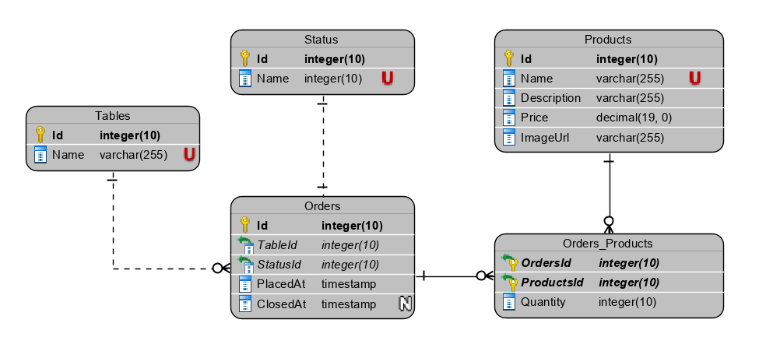

Figure 1 Simple ERD for storing order and product information

There are currently 4 entity tables and 1 pivot table.

When an order is created, the products are attached to the *Order* record using the pivot table, which also contains the quantity of each product. The order will be attached to the correct *Table* entity the order was created on.

The status of the order indicates what action(s) can be taken for the order, such as sending it to the robot if it is still open. Example statuses could be: ‘Created’, ‘Processing’, ‘Closed’ etc.